Packet Tracer - Configure and Verify eBGP (Modified Version)

Student No: Name:

**INSTRUCTIONS**

**Answer the questions marked in Red as you do the Lab.**

**Type your answers to the questions into this doc.**

**Download this Lab doc. Save it with your student number in the filename.**

**Download the Packet Tracer File. Save it with your student number in the filename.**

**Put completed Lab doc AND Packet Tracer File in one Zip file.**

**Upload the Zip to Bright Space at end of Lab today.**

**.**

1. Topology

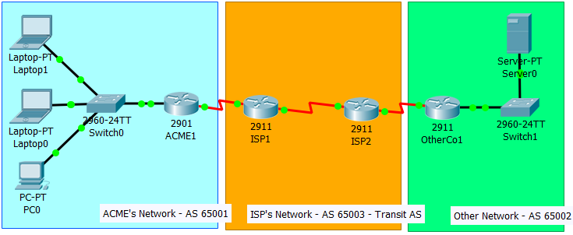

Objectives

Configure and verify eBGP between two autonomous systems.

1. Background / Scenarios

An Autonomous System (AS) “is a set of routers under a single technical administration, using an interior gateway protocol and common metrics to route packets within the AS, and using an **exterior gateway protocol** to route packets to other Autonomous Systems.” (RFC1930 <https://tools.ietf.org/html/rfc1930>).

An AS can also be referred to as a routing domain. This may make the concept a bit clearer.

The de facto exterior gateway protocol used for inter-AS routing on the Internet is BGP4. The Internet is made up of many Autonomous Systems. BGP makes inter-networking possible between Autonomous Systems.

In this activity, you will configure and verify the operation of eBGP between autonomous systems 65001 and 65002. ACME Inc. is a company that has a partnership with Other Company and must exchange routes. Both companies have their own autonomous systems and will use the ISP as the transit AS to reach each other.

**Note**: Only companies with very large networks can afford their own autonomous system.

1. Address Table

|  |  |  |  |  |
| --- | --- | --- | --- | --- |
| Device | Interface | IPv4 Address | Subnet Mask | Default Gateway |
| ACME1 | G0/0 | 192.168.0.1 | 255.255.255.0 | N/A |
| S0/0/0 | 1.1.1.2 | 255.255.255.252 | N/A |
| OtherCo1 | G/0/0 | 172.16.10.1 | 255.255.255.0 | N/A |
| S0/0/0 | 1.1.1.10 | 255.255.255.252 | N/A |
| ISP1 | S0/0/0 | 1.1.1.1 | 255.255.255.252 |  |
| S0/0/1 | 1.1.1.5 | 255.255.255.252 |  |
| ISP2 | S0/0/0 | 1.1.1.9 | 255.255.255.252 |  |
| S0/0/1 | 1.1.1.6 | 255.255.255.252 |  |
| PC0 | NIC | DHCP | | 192.168.0.1 |
| Laptop0 | NIC | DHCP | | 192.168.0.1 |
| Laptop1 | NIC | DHCP | | 192.168.0.1 |
| Server | NIC | 172.16.10.2 | 255.255.255.0 | 172.16.10.1 |

**NB:** The IP addressing is already configured.

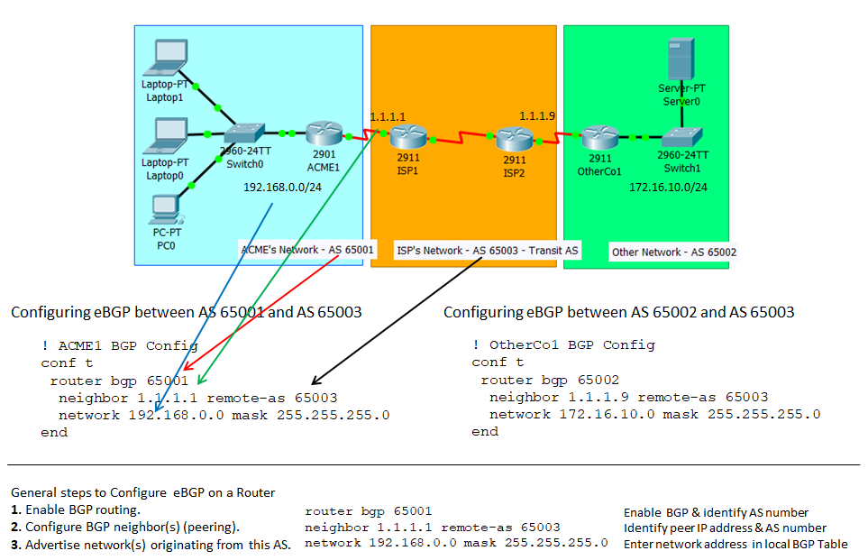

**Figure 1 - Configuring eBGP between two autonomous systems**

* 1. Configure eBGP in ACME Inc.

ACME Inc. hired an ISP to connect ACME to a partner company called Other Company. You must connect ACME to the ISP so that ACME and Other Company can communicate.

ACME, the ISP, and Other Company exist as distinct Autonomous Systems (AS). ACME’s AS number is 65001. The ISP’s AS number is 65003. The Other Company’s AS number is 65002. BGP is used as the inter-AS routing protocol. ACME’s border router is ACME1. The ISP’s border router facing ACME is ISP1.

* + 1. The ISP has established network reachability across its network to the Other Company. Ping from ISP1 Router to the IP address (1.1.1.9) on ISP2 Router’s serial interface s0/0/0. **Does it work? NO**
    2. Ping the Other Company’s server 172.16.10.2 from any device inside ACME’s network. The pings should fail as no BGP routing is configured at this time.
    3. Configure ACME1 Router to become an eBGP peer (neighbor) with ISP1 Router. ACME’s AS number is 65001. The ISP’s AS number is 65003. Use the 1.1.1.1 as the neighbor IP address and make sure to add ACME’s internal network 192.168.0.0/24 to BGP. Figure 1 on page 2 above, shows how the below config commands and their parameters relate to AS65001, AS65002 and AS6503 topologies.

! ACME1

conf t

router bgp 65001

neighbor 1.1.1.1 remote-as 65003

network 192.168.0.0 mask 255.255.255.0

end

What BGP message appeared on ACME1 CLI after configuring ACME1 for BGP?

%SYS-5-CONFIG_I: Configured from console by console

%BGP-5-ADJCHANGE: neighbor 1.1.1.1 Up

**NB:** If no BGP message appeared, check your BGP config script and ensure local and remote AS numbers, internal network IP addresses, and neighbor IP addresses are correct.

When you have configured ACME1 for BGP, ping the Other Company internal server 172.16.10.2 again from any device inside ACME’s network. **Does it work? NO**

* 1. Configure eBGP in Other Company Inc.

The network administrator at Other Company is not familiar with BGP and could not configure their side of the link. You must also configure their end of the connection.

Configure OtherCo1 to form an eBGP adjacency with ISP2, the ISP border router facing OtherCo1. Other Company is under AS 65002 while ISP is under AS 65003. Use the 1.1.1.9 as the neighbor IP address of ISP2 and make sure to add Other Company’s internal network 172.16.10.0/24 to BGP.

The structure of the configuration commands to configure OtherCo1 to form an eBGP adjacency with ISP2 is the same as in Step 1c above, but you will have to change AS number, neighbor IP address, and internal network address. Use Figure 1 on Page 2 as a guide.

What BGP message appeared on OtherCo1 CLI after configuring OtherCo1 for BGP?

%BGP-5-ADJCHANGE: neighbor 1.1.1.9 Up

**NB:** If no BGP message appeared, check your BGP config script and ensure local and remote AS numbers, internal network IP addresses, and neighbor IP addresses are correct.

When you have configured OtherCo1 for BGP, ping the Other Company internal server again 172.16.10.2 from any device inside ACME’s network. **Does it work? YES**

* 1. eBGP Verification
     1. Use the **show ip bgp summary** command to verify all the routes ACME1 has learned via eBGP and their status.

What local IPv4 address has been used as the **BGP router identifier? 192.168.0.1**

What **local AS number** is listed? **65001**

What is the **IPv4 address** and the **AS number** of the **remote BGP neighbour**? 1.1.1.1

What remote BGP gateway router is assigned this IPv4 address? **2**

* + 1. Use the **show ip bgp** command to view ACME1’s BGP Table. This command lists a table of all the networks BGP knows about, the next hop for each network, some of the attributes for each route, and the AS path for each route.

BGP peer routers advertise routes to each other. A Route = Network Prefix + BGP attributes.

BGP attributes = (AS-PATH and NEXT-HOP). You can see the prefix, NEXT-HOP, and AS-Path in the **show ip bgp** command output.

List the Prefix, NEXT-HOP and AS-PATH for the first entry in the BGP Table.

Prefix = 1.1.1.0/30, NEXT-HOP = 1.1.1.1 AS-PATH = 65003

* + 1. Use **show ip route** command to look at the routing tables on ACME1 and OtherCo1.  
       ACME1 should have routes learned about Other Company’s route 172.16.10.0/24.  
       OtherCo1 should now know about ACME’s route 192.168.0.0/24.   
         
       Does a route to Other Company exist in ACME1’s routing table that was learned from BGP? yes  
       Copy and paste the route in here

ROUTER BGP 65001

Does a route to ACME1 exist in Other Company’s routing table that was learned from BGP? YES  
Copy and paste the route in here

ROUTER BGP 65001

How did you know the routes in ACME and Other Company’s routing tables were learned from BGP?  
THE TABLES ARE IDENTICAL TO EACH OTHER

* + 1. Open a web browser in any ACME Inc. end device and navigate to Other Company’s server by entering its IP address 172.16.10.2. Could you access the Web page on the server at 172.16.10.2.? YES
    2. From any ACME Inc. device, ping the Other Company’s server at 172.16.10.2. Was the ping successful? YES
  1. View BGP ‘keep alive’ messages

BGP neighbors send ‘keep alive’ message every 60 seconds (by default) to keep the connection alive. Use Packet Tracer in Simulation Mode to see this happening.

* + 1. Click the **Simulation Tab** in Packet Tracer. The *Simulation Panel* opens.
    2. Click the **ShowAll/None** button at the bottom of the *Simulation Panel* to de-select all the filters.   
       **Note:** If you can’t see **ShowAll/None** button, double-click on the *Simulation Panel heading.* The *Simulation Panel ‘*pops’ out. Drag the *Simulation Panel* upwards. **ShowAll/None** button is at bottom of panel.
    3. Click the **Edit Filters** button. Click *IPv4 tab*. Click the *BGP check box* to choose the BGP Filter.
    4. Click the **Play** button on the *Simulation Panel* to see the ‘keep alive’ messages passing between BGP peers. Let the simulation run until the *Event List* in the *Simulation Panel* has 10 entries. Click **Play** button again to stop simulation.
    5. Take a screen shot of the *Event List* in the *Simulation Panel* and paste it in below.

Screen shot:

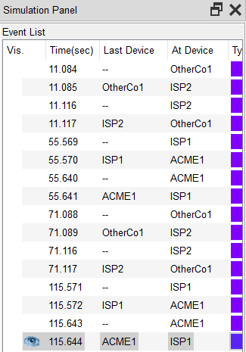

* + 1. Click on the **first packet** in the *Event List* in the *Simulation Panel.* A *PDU Information Window* opens for the packet.
    2. Ensure that the *OSI Model Tab* is selected in the *PDU Information Window*.
    3. Take a screen shot of the *PDU Information Window* and paste it in below.

Screen shot:

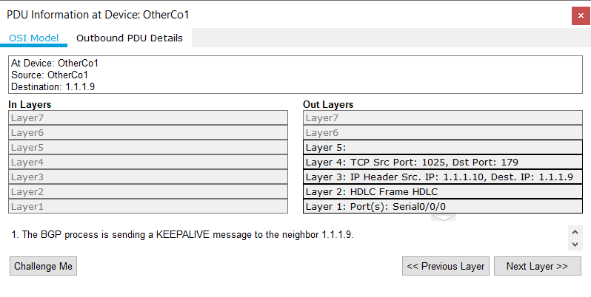

* + 1. From the information shown in the *PDU Information Window*:

Which device is the packet at? OTHERCO1

What is source device for the packet? OTHERCO1

What is the destination device for the packet? 1.1.1.9

Is the BGP process sending or receiving a keepalive message? SENDING

What is the IP address of the neighbour? 1.1.1.9

Which device is the neighbour? ISP2

* + 1. Click on the **second packet** in the *Event List.* A *PDU Information Window* opens for the packet.
    2. Ensure that the *OSI Model Tab* is selected in the *PDU Information Window*.
    3. Take a screen shot of the *PDU Information Window* and paste it in below.

Screen shot: ………………….

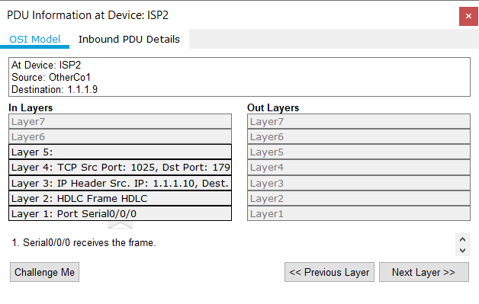

* + 1. From the information shown in the *PDU Information Window*:

Which device is the packet at? ISP2

What is the source device for the packet? OTHERCO1

What is the destination device for the packet? 1.1.1.9

Is the BGP process sending or receiving a keepalive message? RECEIVING

**Note:** If you see the message “Serial0/0/0 receives the frame”, instead of info about keepalive messages click the *Next Layer Button* at the bottom of the *PDU Information Window* four times to go up the OSI ‘stack’ to the info about the BGP process sending or receiving keepalive messages.

What is the IP address of the neighbour? 1.1.1.10

Which device is the neighbour? OTHERCO1